Data Analysis For All 12 Heart Rate Samples

**Recording 1 Analysis:**

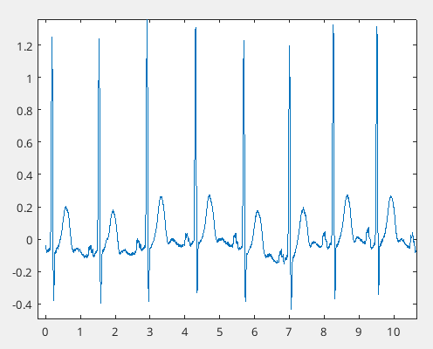

In the figure above, the peak prominence for the heart rate seems to be defined past around 0.5. By using the findpeaks functions with the MinPeakProminance at 0.5, the following heart rates are found per minute.

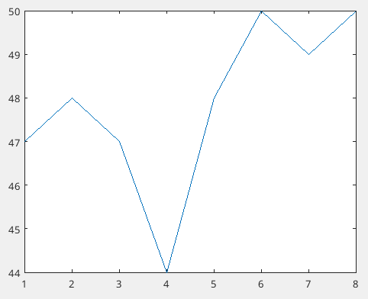

From the graph above, the average heart rate per minute is 47.875. After calculating the heart rate variability, the following graph is generated.

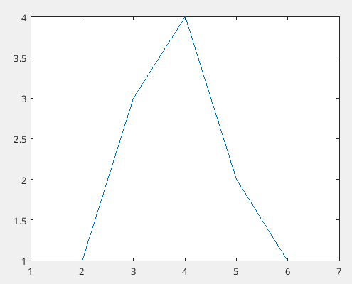

The average heart rate variability is 1.8571 based on the graph above. The heart rate seems to have a big change in the middle of the sample, then starts to level out at the end.

**Recording 2 Analysis:**

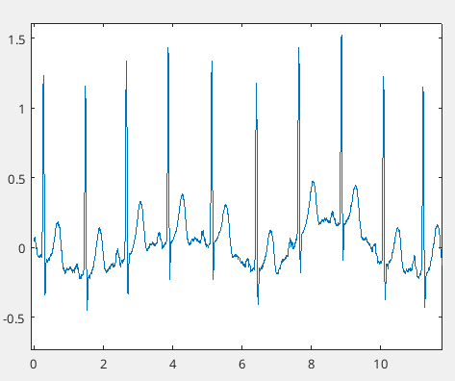

After plotting the second sample in seconds, the MinPeakProminance seems to still be at 0.5 as the lowest it can go before it starts to mislabel peaks. After calculating the heart rate per minute with a MinPeakProminance as 0.5, the following graph is generated.

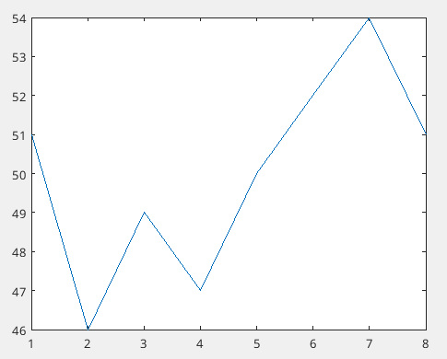

The average heart rate per minute for this sample is 50 beats per minute. Calculating the variance in heart rate for this sample provides the following graph.

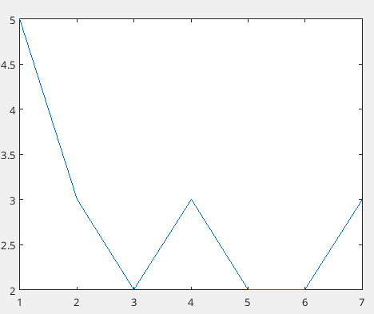

The graph shows a large change in the beginning of the sample, then a leveling of the sample at the end. The sample always has a minimum change of 2, meaning that no two values in the heart beats per minute are the same. The average variability is 2.8571.

**Recording 3 Analysis:**

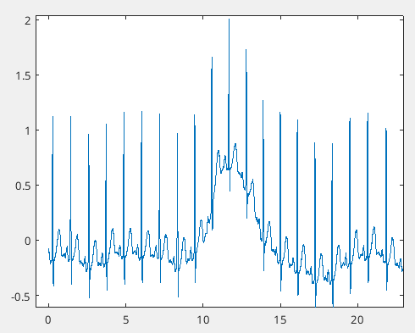

For the third sample, there is more variation in the heart rate compared to the previous samples, In this case, the MinPeakProminance will be set to 0.9 to properly read these peaks. The value of 0.9 is chosen since it doesn’t go over the maximum of the other peaks, but still passes over the variation in the sample. After getting the heart rate based on the MinPeakProminance value, the following graph is generated.

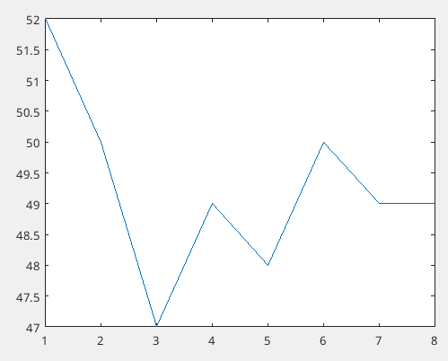

The average heart rate per minute is 49.25 beats per minute. Initially, the heart rate is high, but it seems to level out after the third minute. Plotting the variance leads to the following graph.

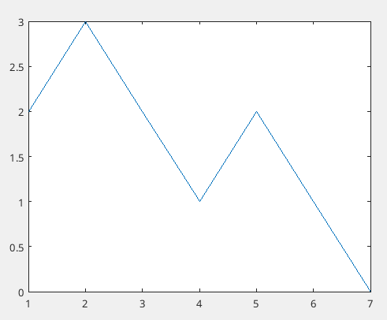

Just like the heart rate per minute graph, there is high variance in the beginning of the sample, but the variance starts to die down after the 3rd minute, even going down to 0 at the last minute.

**Recording 4 Analysis:**

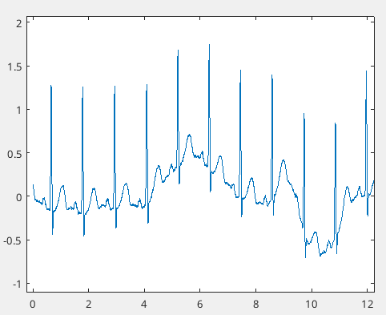

For the 4th sample, there are a lot of dips, meaning that the MinPeakProminance must be a little lower than before. To overcome the small peaks like those between 5 and 8 seconds and the dips at 10, a MinPeakProminance of 0.8 is used.

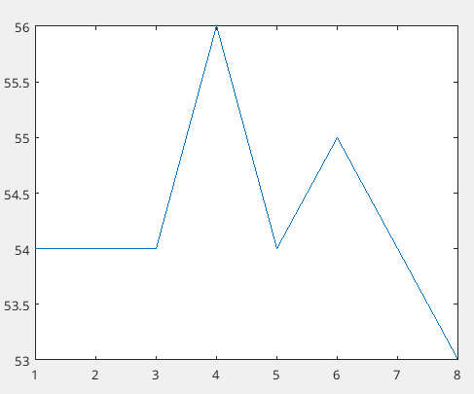

The heart rate per minute seems to be pretty stable, with a max variance change of 2 beats per minute (54 BPM to 56 BPM). The average beats per minute is 54.25. This is a little higher than the previous samples. After calculating the variance in heart rate, the following graph is generated.

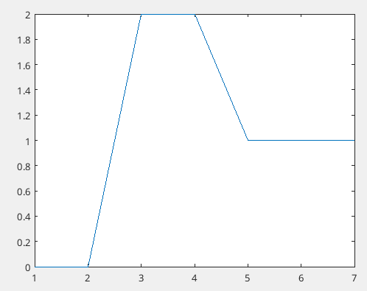

The variance graph shows a maximum change of 2 BPM being at time steps 3 and 4. The average variance is 1 BPM.

**Recording 5 Analysis:**

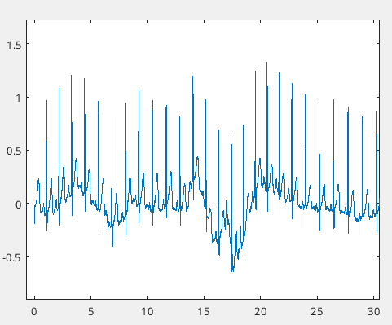

After plotting the data in seconds, a MinPeakProminance value of 0.7 will be used since it seems to be the smallest value possible before starting to misclassify heart beats.

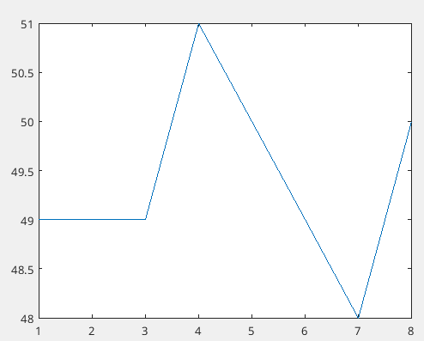

After plotting beats per minute, the values are found to be pretty stable just like the last sample. The average beats per minute is 49.3750. After plotting the variance in these changes, the following graph is found.

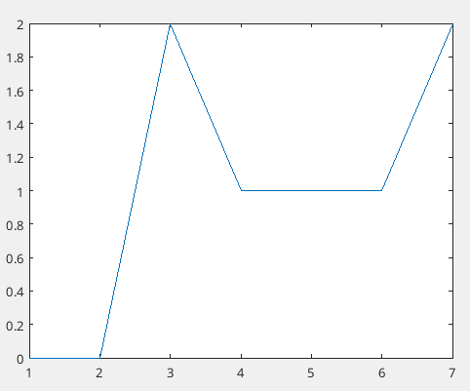

The maximum change in BPM is 2, with an average variance of 1.

**Recording 6 Analysis:**

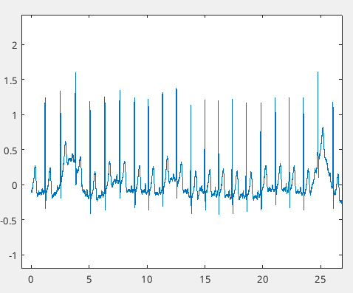

After plotting this sample, a MinPeakProminance of 0.9 will be used. At 25 seconds, a visible increased peak can be observed. This dataset contains a lot of those types of peaks, which is why a value of 0.9 was chosen.

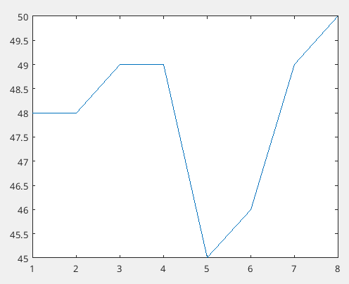

After plotting the beats per minute, the graph above is generated. The values seem to have more variance than the previous sample, with a maximum change of 4 BPM. The average beats per minute is 48 beats per minute.

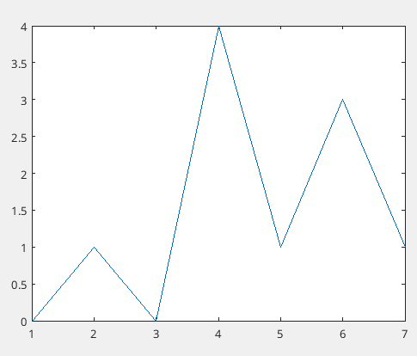

After plotting the variance, a maximum variance of 4 can be found. The average variance for this sample is 1.4286.

**Recording 7 Analysis:**

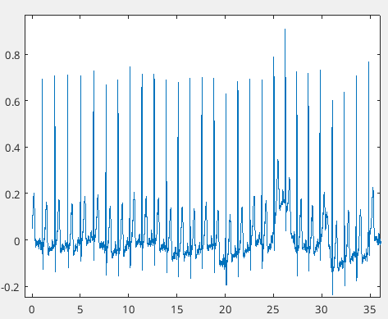

In this sample, the MinPeakProminance will be set to 0.5 since the values seem to be much lower than the previous data sets. If a higher MinPeakProminance is chosen, there is a high likelihood of heart rates not being detected.

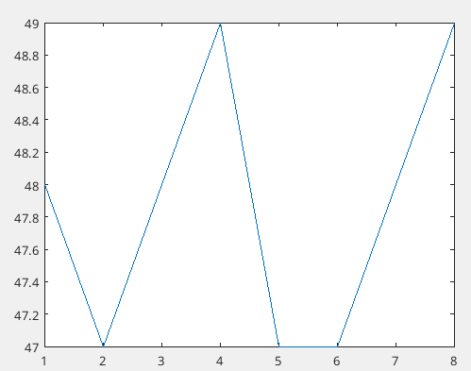

After plotting the heart rate per minute, the values can be seen to be around the previous samples. The average beats per minute is 48.8750.

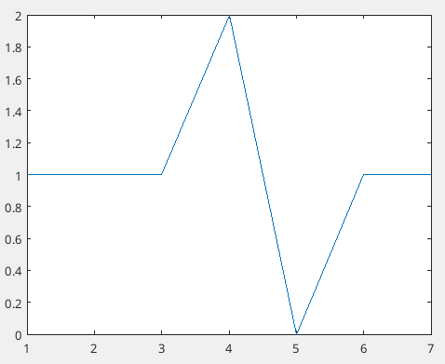

After plotting the variance, a maximum change of 2 can be found. The average variance in this sample is 1 BPM.

**Recording 8 Analysis:**

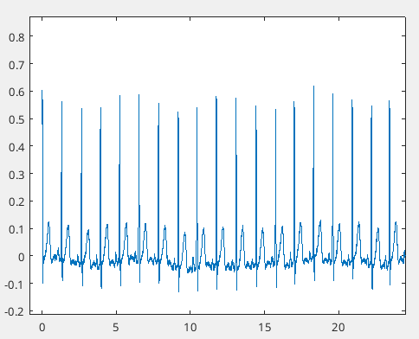

In this sample’s data, the MinPeakProminance will be set to 0.3. The height of the signals seem to be a lot lower than the previous samples.

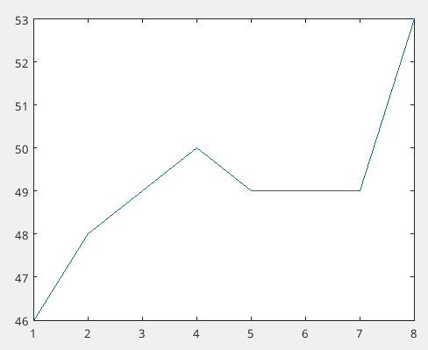

For this sample, it seems the patient’s heart rate was increasing for the data collection time. The average beats per minute is 49.1250.

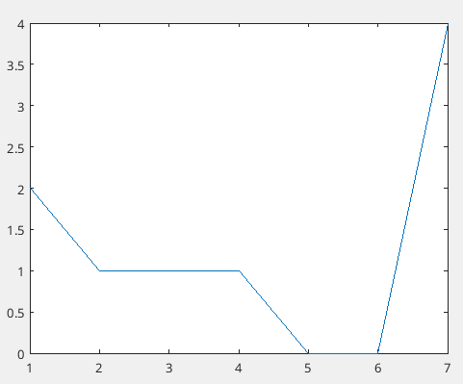

The variance in the beats per minute shows a maximum change of 4 beats. The average variance is 1.2857 beats per minute.

**Recording 9 Analysis:**

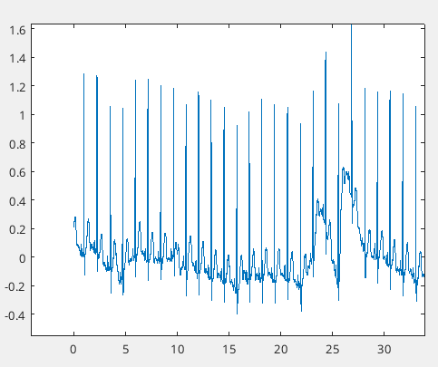

In this sample set, the values seem to return back to the original maximum values. A MinPeakProminance of 0.8 will be chosen for this set for beat per minute calculation.

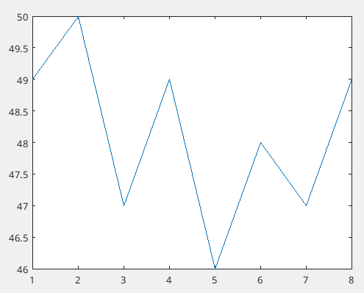

The BPM seems to have a downward trend until 5 minutes, then it starts to increase. The average BPM for this set is 48.125.

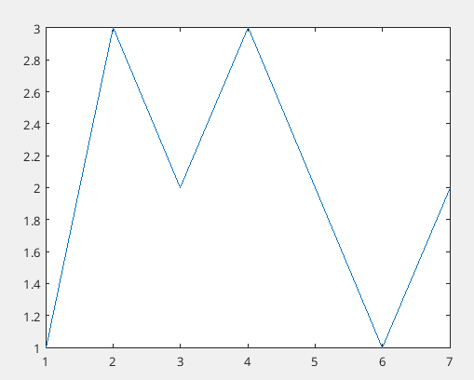

Plotting the heart variance shows that the maximum change in BPM is 3. The average variance for this set is 2 BPM.

**Recording 10 Analysis:**

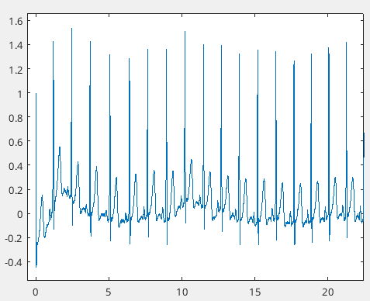

This sample’s dataset has a very consistent amplitude. Due to this, a MinPeakProminance of 0.6 will be chosen.

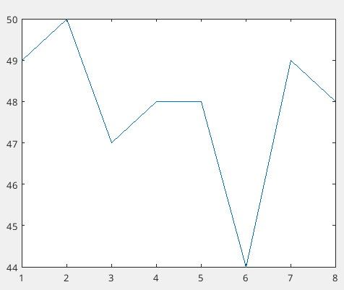

After plotting the BPM, the maximum BPM found is at 2 minutes, being 50 beats per minute. The average BPM for this sample is 47.875.

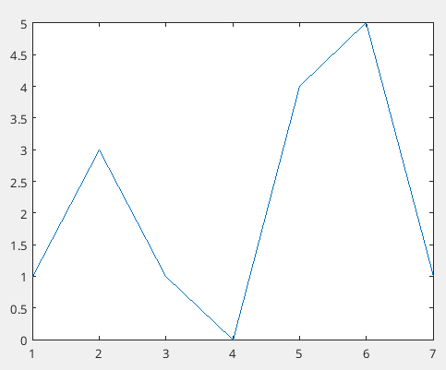

Plotting the variance finds that the highest variance occurs at 6 minutes, being a 5 BPM change. The average variance in this sample is 2.1429 BPM.

**Recording 11 Analysis:**

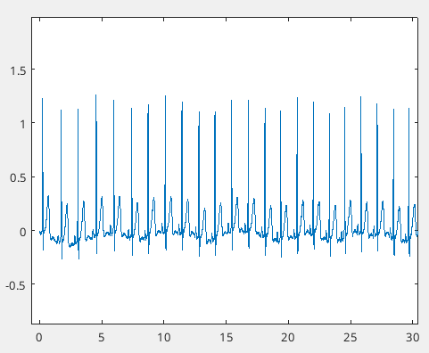

In this set, the amplitudes seem to have gone back down again. A MinPeakProminance of 0.5 will be chosen for beat per minute detection.

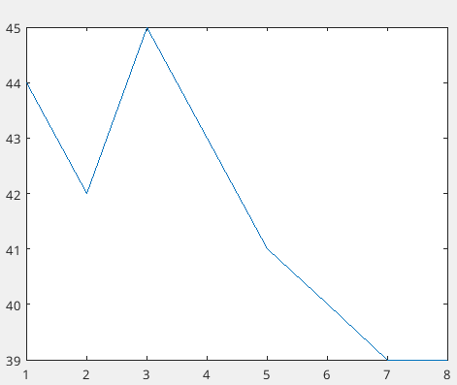

After plotting beats per minute, a maximum beats per minute of 45 beats can be found. Interestingly, the minimum beats per minute is lower than the rest of the samples, being 39 BPM. The average BPM for this sample is 41.625.

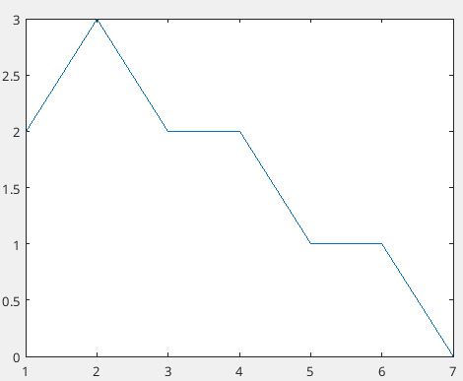

After plotting the variance difference, a max variance of 3 can be found at 2 minutes. The average variance is 1.5714.

**Recording 12 Analysis:**

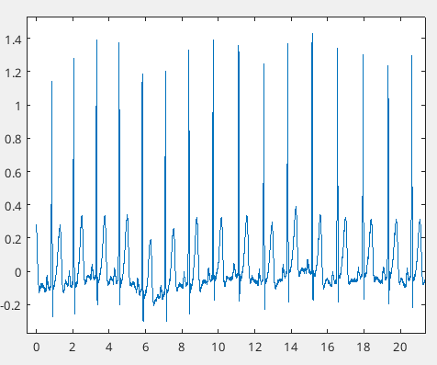

After plotting the data for this sample, a MinPeakProminance of 0.6 will be chosen.

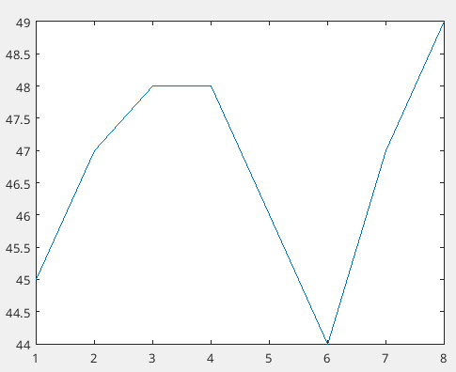

After plotting the BPM, a maximum beat per minute is found to be 49 at 8 minutes. The average beats per minute is 46.75.

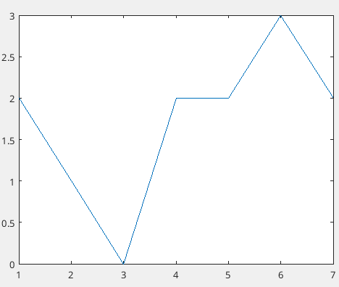

After plotting the variance in the BPM, a maximum variance of 3 can be found at 6 minutes. The average variance for this dataset is 1.7143.